
SIMATS ENGINEERING
Saveetha Institute of Medical and Technical Sciences
Chennai-602105

AQUAGUARD 360: INTELLIGENT WATER QUALITY MONITORING AND PREDICTIVE CONTAMINATION ALERT SYSTEM

S ROOPAN RAJ(192525474)
B.Tech AI&ML

DECLARATION

I hereby declare that the project entitled "AquaGuard 360: Intelligent Water Quality Monitoring and Predictive Contamination Alert System" submitted in partial fulfillment of the requirements for the award of the degree of Bachelor of Engineering in Artificial Intelligence and Machine Learning is a record of original work carried out by me under the guidance of Dr. ANITADAVAMANI, Department of Artificial Intelligence and Machine Learning, Saveetha Engineering College.
I further declare that this project has not previously formed the basis for the award of any degree, diploma, associate ship, fellowship, or any other similar title in any University or Institution.

Date: 6/08/2026 Signature of the Student
Place: Chennai S. ROOPAN RAJ

ACKNOWLEDGEMENT
I express my sincere gratitude to Saveetha Engineering College, Chennai, for providing an excellent academic environment and the necessary facilities to carry out this project successfully.
I extend my heartfelt thanks to the Principal of Saveetha Engineering College for providing continuous encouragement, motivation, and institutional support throughout the completion of this project.
I express my sincere gratitude to the Head of the Department of Artificial Intelligence and Machine Learning for providing valuable guidance, encouragement, and the necessary infrastructure required for the successful completion of this work.
I am deeply indebted to my project guide, Dr. ANITADAVAMANI, for their constant encouragement, technical expertise, valuable suggestions, and continuous supervision throughout every stage of this project. Their guidance played a vital role in shaping this work into its present form.
I also thank all the faculty members of the Department of Artificial Intelligence and Machine Learning for sharing their knowledge and extending their support whenever required.
Finally, I express my heartfelt gratitude to my parents, family members, friends, and classmates for their unwavering encouragement, motivation, and moral support throughout the development of this project.

1. INTRODUCTION
Water quality monitoring is essential for protecting public health, maintaining environmental sustainability, and supporting the safe use of water resources. Water sources can be affected by industrial discharge, agricultural runoff, microbial contamination, and environmental changes. Continuous observation of water quality is therefore important for identifying abnormal conditions and supporting timely action.
Traditional water quality monitoring often depends on periodic sample collection followed by laboratory analysis. Although laboratory testing provides detailed information about water conditions, the process may require considerable time before results become available. Furthermore, periodic sampling cannot continuously observe changes occurring between two testing intervals.
AquaGuard 360 is proposed as an intelligent water quality monitoring and predictive contamination alert system. The system combines Internet of Things (IoT) sensors, cloud computing, artificial intelligence, machine learning, centralized data storage, dashboards, and notification mechanisms to provide continuous monitoring and predictive analysis of water quality.
IoT sensors installed at different water sources collect parameters such as pH, turbidity, temperature, dissolved oxygen, conductivity, and supported contaminant measurements. The collected sensor information is transmitted to the AquaGuard 360 platform, where it is validated and stored. AI/ML models analyze current and historical measurements to detect unusual patterns and estimate possible contamination risks.
The system also provides a centralized dashboard through which authorized stakeholders can observe current water conditions, historical trends, predictions, and alerts. When significant abnormal conditions are identified, the system generates notifications so that responsible personnel can investigate the affected water source.
The architecture of AquaGuard 360 must therefore support continuous data collection, high volumes of sensor information, analytical processing, reliable storage, secure user access, and timely alert generation. These requirements directly influence the selection and design of the software architecture.

2. SYSTEM OBJECTIVES
The primary objective of AquaGuard 360 is to provide a centralized intelligent platform capable of continuously monitoring water quality across multiple locations. Instead of depending entirely on periodic manual monitoring, the system uses IoT sensors to repeatedly collect measurements and transmit them to the centralized platform.
Another major objective is to provide early identification of potential water quality problems. Current measurements alone indicate the present condition of the monitored water source, while historical information provides patterns of how those conditions have changed over time. AquaGuard 360 combines these sources of information and applies AI/ML techniques to detect abnormalities and predict possible contamination risks.
The system is also intended to improve accessibility of monitoring information. Water Utility Operators and Environmental Officers should not need to manually combine data from several separate monitoring locations. A centralized dashboard should provide access to live measurements, historical information, analytical results, and active alerts.
Timely communication is another important objective. When AquaGuard 360 detects an abnormal condition or significant predicted contamination risk, the platform should generate an alert and provide relevant information to authorized stakeholders.
The overall objectives of AquaGuard 360 are therefore to provide continuous monitoring, centralized information management, predictive analysis, early contamination alerts, historical analysis, automated reporting, and support for monitoring multiple water sources.

3. FUNCTIONAL REQUIREMENTS
Functional requirements describe the operations that AquaGuard 360 must perform. These requirements have a direct influence on the architectural components required by the proposed system.
User and Access Management
AquaGuard 360 must provide authentication for registered users. After successful authentication, access to system functionality should depend on the user's assigned role. For example, Water Utility Operators may access monitoring and alert functionality, while System Administrators require additional privileges for managing users, sensors, and monitoring locations.
Role-based access control is required because the platform contains both operational information and administrative functionality. Ordinary monitoring users should not be able to modify critical system configurations.
IoT Sensor and Water Source Management
The platform must support registration and management of multiple water sources, monitoring locations, and IoT sensors. Every sensor should have a unique identity and should be associated with the correct monitoring location and measured parameter.
AquaGuard 360 should also maintain information regarding sensor operational status. If a sensor stops communicating, the platform should distinguish the absence of measurements from normal water conditions.
Real-Time Data Collection
The system must continuously receive measurements from registered IoT sensors. Supported measurements include pH, turbidity, temperature, dissolved oxygen, conductivity, and available contaminant information.
Incoming measurements should contain sufficient information to identify the sensor, measured parameter, value, and time of measurement. The system must validate incoming information before storing and processing it.
Because several sensors may transmit information simultaneously, the architecture must support continuous data ingestion from multiple monitoring locations.

Data Storage and Historical Analysis
Validated measurements must be maintained in centralized storage. Historical data is required for both user analysis and AI/ML processing.
Authorized users should be able to retrieve previous measurements based on parameters such as monitoring location, water quality parameter, and time period. Historical information should be available for visualization and report generation.
AI/ML Analysis
AquaGuard 360 must analyze current and historical sensor information to identify unusual water quality behaviour. The analytical component should support anomaly detection and contamination-risk prediction.
The AI/ML functionality should operate independently from direct sensor collection so that analytical models can be modified or improved without redesigning the complete IoT monitoring process.
Dashboard and Visualization
Authorized stakeholders must be able to access monitoring information through a centralized dashboard. The interface should display current measurements, historical trends, predictive information, and active alerts.
The dashboard should support multiple monitoring locations and allow users to select the water source or parameter they want to investigate.
Alerts and Notifications
The system must generate alerts when abnormal water quality conditions or significant predicted risks are detected. Alerts should contain information such as the affected location, condition, timestamp, and severity.
Generated alerts should be displayed through the AquaGuard 360 dashboard and passed to an appropriate notification mechanism so that responsible personnel can be informed.
Reporting
Authorized users should be able to generate reports containing selected monitoring information, historical trends, predictions, and alert records. Reporting functionality should support operational analysis and regulatory documentation.
The major functional requirements can be summarized as follows:
ID | Functional Requirement
FR-01 | Authenticate registered users
FR-02 | Provide role-based access control
FR-03 | Manage water sources and monitoring locations
FR-04 | Register and manage IoT sensors
FR-05 | Monitor sensor operational status
FR-06 | Collect real-time water quality measurements
FR-07 | Validate incoming sensor information
FR-08 | Store measurements in centralized storage
FR-09 | Retrieve historical monitoring information
FR-10 | Display live and historical data through dashboards
FR-11 | Detect abnormal water quality conditions
FR-12 | Predict contamination risk using AI/ML
FR-13 | Generate and communicate alerts
FR-14 | Maintain alert history
FR-15 | Generate monitoring and compliance reports
FR-16 | Support centralized monitoring of multiple locations

4. NON-FUNCTIONAL REQUIREMENTS
Non-functional requirements describe the quality characteristics expected from AquaGuard 360. These requirements are particularly important for architecture design because they influence how the different components of the system should be organized.
Performance is important because the system receives continuous sensor information. Measurements should be processed with sufficiently low delay to support near-real-time monitoring. Alert processing should also occur quickly enough for stakeholders to respond to abnormal conditions.
Reliability is required because inaccurate or unavailable monitoring information can affect decision-making. Failure of one sensor should not cause the entire platform to stop functioning. The system should identify missing or invalid information while continuing to process measurements from other available sensors.
Availability is also important because water conditions can change at any time. The centralized monitoring platform should therefore be designed for continuous operation, with suitable recovery mechanisms for important components.
Security must protect both monitoring information and system configuration. Users must be authenticated, permissions should be role-based, and communication between important system components should use appropriate protection mechanisms.
Scalability is required because AquaGuard 360 may initially monitor only a limited number of water sources but should support future expansion. The architecture should allow additional sensors, monitoring locations, users, and increasing quantities of historical information without requiring a complete redesign.
Maintainability is necessary because IoT communication mechanisms, analytical models, dashboards, and reporting functionality may evolve independently. A modular architecture will allow individual components to be updated with reduced impact on unrelated parts of the system.
The primary non-functional requirements are summarized below.
ID | Quality Attribute | Requirement
NFR-01 | Performance | Process sensor information with low monitoring delay
NFR-02 | Reliability | Continue operation when individual sensors fail
NFR-03 | Availability | Support continuous monitoring
NFR-04 | Security | Provide authenticated and role-based access
NFR-05 | Security | Protect transmitted and stored information
NFR-06 | Scalability | Support additional sensors and locations
NFR-07 | Scalability | Handle increasing historical data volume
NFR-08 | Maintainability | Maintain modular and independently manageable components
NFR-09 | Data Integrity | Preserve correct sensor, location, value, and timestamp relationships
NFR-10 | Recovery | Support backup and recovery of important monitoring data

5. QUALITY ATTRIBUTES INFLUENCING ARCHITECTURE

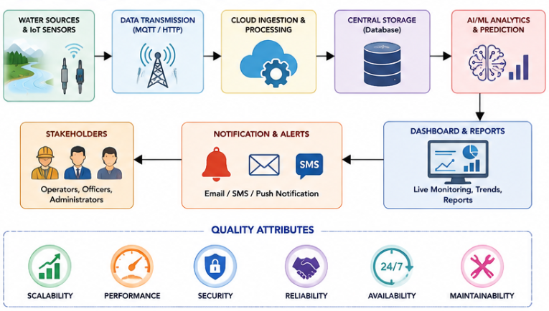

6. ARCHITECTURE SELECTION
For AquaGuard 360, a Hybrid Layered and Event-Driven Architecture is selected. A hybrid approach is suitable because the system contains two different types of operations. First, AquaGuard 360 continuously receives events from IoT sensors and must process abnormal conditions quickly. Second, it provides structured application functionality such as authentication, dashboards, reporting, historical analysis and administration.
The Event-Driven Architecture is used primarily for sensor-data acquisition and alert processing. Every new sensor measurement can be considered an event. Instead of tightly coupling sensors directly with analytical and dashboard components, sensor information is transmitted through a messaging mechanism. This allows data producers and consumers to operate more independently.
The Layered Architecture organizes the main application into logical responsibilities. The proposed layers are the IoT/device layer, communication and ingestion layer, application/service layer, AI/ML analytics layer, data layer and presentation layer. Each layer performs a specific responsibility and communicates through defined interfaces.
Combining these approaches provides a practical architecture for AquaGuard 360. Event-driven communication supports continuous sensor processing and scalability, while layered organization improves maintainability and separation of responsibilities.

7. JUSTIFICATION OF THE SELECTED ARCHITECTURE
A simple monolithic architecture would initially be easier to develop, but sensor ingestion, AI processing, dashboards, notifications and reporting would become tightly connected. As the number of sensors and monitoring locations increases, modifications to one area could affect unrelated functionality.
A purely layered architecture provides good separation of responsibilities but is less suitable by itself for continuously arriving asynchronous IoT events. AquaGuard 360 may receive measurements from many sensors without direct user interaction. These events must be accepted and processed independently of dashboard requests.
Event-driven processing solves this issue by allowing IoT measurements to be published to a messaging component. Processing services can consume the information as it becomes available. The sensor does not need direct knowledge of the database, AI model or notification service.
The layered portion of the architecture remains useful for user-facing functionality. Authentication, APIs, dashboards, reporting and administrative operations can be organized into separate logical layers with clearly defined responsibilities.

The selected hybrid architecture therefore supports the major AquaGuard 360 architectural requirements:
Requirement | Architectural Support
Continuous sensor monitoring | Event-driven data ingestion
Multiple sensors and locations | Scalable messaging and processing
AI/ML prediction | Independent analytics component
Centralized historical data | Dedicated data layer
Live dashboard | API and presentation layer
Rapid alerts | Event-based alert service
Security | Authentication and API access control
Maintainability | Separation of architectural components
Future expansion | Components can be extended independently

8. DETAILED SOFTWARE ARCHITECTURE
The AquaGuard 360 architecture begins with the physical monitoring environment. IoT sensors installed at water sources measure pH, turbidity, temperature, dissolved oxygen, conductivity and other supported parameters.
Sensor information is transferred to an IoT Gateway. The gateway provides a controlled communication point between field devices and the cloud environment. It can perform basic device identification and forward measurements to the data-ingestion infrastructure.
For event-oriented sensor communication, a lightweight protocol such as MQTT can be used. Sensors or gateways publish measurements, while the cloud-side ingestion service consumes the corresponding messages. The use of a message broker reduces direct dependencies between physical devices and backend processing services.
The Data Ingestion and Validation Service verifies incoming measurements. It checks whether the sensor is registered and whether required information such as sensor identifier, value and timestamp is available. Accepted measurements are then passed for storage and analytical processing.
The Central Data Storage Layer maintains sensor information, users, monitoring locations, measurements, predictions and alerts. Historical sensor measurements provide the dataset required for trend visualization and AI/ML analysis.
The AI/ML Analytics Engine receives validated current and historical information. It performs anomaly detection and contamination-risk prediction. Prediction results are returned to the application and can also generate events when significant risks are detected.
An Alert and Notification Service processes abnormal-condition events. The service creates an alert record and sends the relevant information to supported external notification services such as email, SMS or push-notification systems.
The Application/API Layer provides controlled access to monitoring information. Web or mobile clients can request current measurements, historical information, alerts, predictions and reports through defined APIs.
Finally, the Presentation Layer provides the AquaGuard 360 dashboard. Water Utility Operators, Environmental Officers, Administrators and other authorized users interact with the platform through this interface.
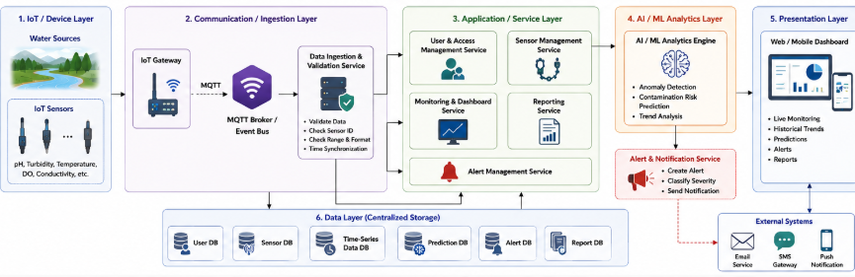

9. ARCHITECTURAL COMPONENTS
The major components of AquaGuard 360 have clearly separated responsibilities.
IoT Sensors and Gateway
IoT sensors form the data-source component of the architecture. Each sensor collects a specific environmental parameter and associates the measurement with a sensor identity and timestamp. The IoT Gateway collects or forwards sensor information to the centralized platform.
Using a gateway also provides a separation between physical sensor technologies and the cloud application. Changes to individual sensor hardware should therefore have limited impact on higher application layers as long as the required data format is maintained.
Message Broker / Event Bus
The Message Broker provides asynchronous communication between IoT data producers and processing components. MQTT is suitable for lightweight IoT messaging, while the exact broker implementation can be selected during deployment.
The broker allows sensor measurements to be queued and processed without requiring the sensors to communicate directly with every downstream component.
Data Ingestion and Validation Service
This component receives incoming sensor events and performs initial processing. It validates sensor identity, measurement structure, parameter information and timestamps before allowing information to enter the main data-processing pipeline.
Invalid information can be rejected or marked for further investigation. This reduces the possibility of malformed data directly influencing analytics.
Central Database
The database maintains persistent AquaGuard 360 information. It stores registered users, roles, water sources, monitoring locations, sensors, sensor readings, predictions, alerts and reporting information.
Historical storage is particularly important because AI/ML models and trend visualization depend on previous measurements.
AI/ML Analytics Engine
The analytics component processes current and historical measurements. It supports anomaly detection and contamination-risk prediction.
Keeping AI/ML processing as a separate architectural component improves maintainability. Analytical models can be retrained or replaced without redesigning the complete sensor-ingestion or dashboard architecture.
Application and API Layer
The Application/API Layer provides the business functionality used by client applications. It handles requests for monitoring information, historical data, predictions, alerts and reports.
REST APIs can provide standardized communication between the dashboard and backend services. Authentication and authorization checks are applied before protected information is returned.
Dashboard
The dashboard represents the primary interface for human stakeholders. It displays current water quality values, historical trends, predictions and alerts.
The presentation component should not directly access physical sensors or database tables. Instead, it communicates through the application/API layer. This maintains separation between presentation and backend responsibilities.
Alert and Notification Service
The Alert Service receives abnormal-condition or high-risk events generated by the analytical process. It records the alert and passes notification information to the configured communication service.
Separating notifications from analytics means that changes to email, SMS or push-notification providers do not require major changes to the AI/ML model.

10. COMPONENT INTERACTION AND DATA FLOW
The normal AquaGuard 360 workflow begins when an IoT sensor measures a water quality parameter. The measurement is transferred through the IoT Gateway and published through the messaging infrastructure.
The Data Ingestion Service consumes the event and validates the measurement. Valid data is stored in the central database. The measurement may then be made immediately available for dashboard monitoring while also being passed to the analytical component.
The AI/ML Analytics Engine combines the new measurement with relevant historical information. The model evaluates the data for abnormal patterns and contamination risk.
If the result represents a normal condition, the prediction is stored and monitoring continues. If an abnormal condition or significant contamination risk is detected, an alert event is generated.
The Alert Service processes this event, stores the alert and forwards notification information to the appropriate external communication service. Authorized stakeholders can then open the AquaGuard 360 dashboard to inspect current measurements, historical trends and prediction results.
When a user requests information from the dashboard, the request travels through the Application/API Layer. The backend verifies the user's authentication and permissions, retrieves the required information and returns it to the presentation layer.
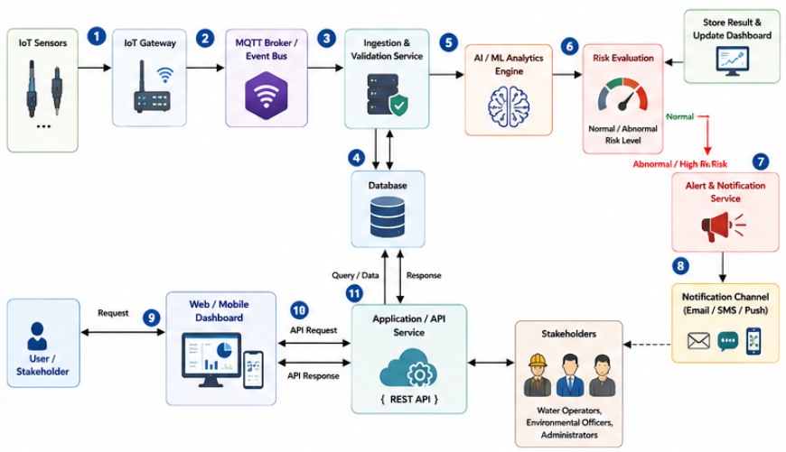
11. APIs, DATABASE AND EXTERNAL SYSTEMS
Communication between AquaGuard 360 components should occur through defined interfaces. This reduces direct dependencies and allows individual components to be modified more easily.
The IoT communication interface can use MQTT for sensor-data transmission. MQTT is suitable for lightweight publish/subscribe communication and allows multiple sensor events to be handled asynchronously.
The dashboard can communicate with backend application services using REST APIs over HTTPS. Example logical API operations include requesting current measurements, retrieving historical readings, obtaining active alerts and generating reports. Protected API operations require authenticated access.
The AI/ML component communicates with the application or processing service through a defined analytical interface. It receives prepared measurement information and returns prediction results such as normal status, anomaly indication or contamination-risk classification.
The database interface is responsible for persistent storage. Sensor readings can grow rapidly because measurements may be collected continuously from multiple locations. The storage architecture should therefore support efficient time-based retrieval of historical sensor information.
External systems include the IoT Sensor Network and third-party notification providers. Notification services may support email, SMS or application notifications. These external integrations should be accessed through defined interfaces so that the core AquaGuard 360 application is not dependent on one specific provider.

12. ARCHITECTURAL DATA FLOW
The architecture supports two important forms of communication.
The first is asynchronous event-driven communication. Sensor measurements and abnormal-condition events are processed as they occur. The sender does not need to wait for every downstream operation to complete. This is particularly useful for IoT data ingestion and alert generation.
The second is synchronous request-response communication. When a user opens the dashboard or requests a report, the client sends a request to the API and waits for a response. This interaction is more appropriate for user-facing functionality where an immediate result is expected.
Using both communication styles is one of the main reasons for selecting a hybrid architecture. AquaGuard 360 is neither entirely event-driven nor entirely request-response based.
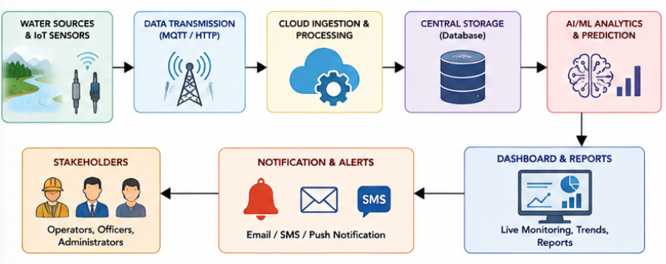

13. QUALITY ATTRIBUTE ANALYSIS
Quality attributes influence how AquaGuard 360 behaves under real operating conditions. Since the system continuously receives measurements from distributed IoT sensors and provides monitoring and predictive services to multiple stakeholders, architectural quality is especially important.
Scalability
AquaGuard 360 should support an increasing number of sensors, monitoring locations and users without requiring a complete redesign. As deployment expands, hundreds or potentially thousands of sensor measurements may arrive continuously.
The event-driven portion of the architecture supports scalability by separating sensor-data producers from consumers. Sensors publish measurements through the MQTT messaging infrastructure instead of directly communicating with every processing component. Additional processing instances can therefore be introduced when the volume of incoming sensor data increases.
The layered design also supports independent scaling. For example, if AI/ML analysis requires greater processing capacity, additional analytical resources can be introduced without necessarily increasing the resources allocated to reporting or user-management functionality.
Centralized storage must similarly be capable of handling increasing historical data. Since sensor readings are time-oriented, efficient time-series storage and indexing strategies can support long-term monitoring across multiple locations.

Performance
Performance is important because AquaGuard 360 is intended to provide near-real-time monitoring and contamination alerts. Excessive delay between sensor measurement and analysis would reduce the usefulness of the system.
The event-driven pipeline allows measurements to enter the processing environment as soon as they are published. The ingestion service performs validation before forwarding accepted information for storage and analysis.
Frequently requested dashboard information, such as the latest sensor readings, should be retrieved efficiently. Historical queries should be optimized so that large quantities of older measurements do not unnecessarily slow current monitoring operations.
Alert processing should receive particular attention. When the AI/ML component identifies a significant contamination risk, the alert event should be forwarded immediately to the notification service instead of waiting for unrelated reporting or dashboard operations.

Security
AquaGuard 360 contains environmental monitoring information and administrative functionality that must be protected from unauthorized access or modification.
At the user level, the architecture supports authentication and role-based authorization. A Water Utility Operator, Environmental Officer and System Administrator should not automatically receive identical permissions.
Communication between the dashboard and backend APIs should use protected communication such as HTTPS. API requests should be authenticated before protected monitoring or administrative information is returned.
The IoT communication layer must also ensure that measurements originate from registered devices. Device identification and validation reduce the possibility of unauthorized or malformed sensor information entering the monitoring pipeline.
Stored information should be protected through appropriate access controls, while sensitive credentials should not be stored as plain text. Important administrative actions can also be recorded through audit logs.

Reliability
Reliability refers to the ability of AquaGuard 360 to perform its required functions consistently. Since the architecture consists of several independent components, failure of one component should not automatically cause failure of the complete platform.
For example, if one IoT sensor stops communicating, other sensors should continue sending measurements. Similarly, temporary failure of the reporting component should not stop real-time sensor ingestion or alert processing.
The message broker provides additional separation between data producers and consumers. Temporary delays in downstream processing can therefore be handled more effectively than in a tightly coupled architecture where every component must be available simultaneously.
Sensor readings should also be validated before they are used for AI/ML processing. This reduces the possibility that malformed data directly affects predictions.

Availability
Water quality conditions may change at any time, so AquaGuard 360 should be designed for continuous operation. Critical components such as sensor ingestion, storage, AI analysis and alert management should have higher availability requirements than optional functions.
The architecture allows important components to be deployed independently. Backup and recovery mechanisms should protect historical data, while monitoring should be used to identify unavailable services.
The system should also distinguish between system failure and sensor failure. If one monitoring device becomes unavailable, the dashboard should indicate missing sensor information while the remaining platform continues operating.

Maintainability
AquaGuard 360 combines several technologies that may evolve independently. IoT protocols may change, AI/ML models may be retrained, dashboards may be redesigned and notification providers may be replaced.
The layered architecture improves maintainability by separating these responsibilities. For example, the AI/ML engine can be modified without changing the physical sensor interface, while the notification provider can be replaced without redesigning the contamination-prediction model.
Defined APIs and message formats further reduce dependencies between components. Developers can therefore understand and maintain individual areas of the system more easily.
The relationship between quality attributes and architectural mechanisms is summarized below.
Quality Attribute | Architectural Mechanism
Scalability | Event broker, independent services, scalable storage
Performance | Asynchronous processing, efficient APIs and optimized data access
Security | Authentication, RBAC, HTTPS and device validation
Reliability | Component isolation, data validation and messaging
Availability | Independent deployment, monitoring, backup and recovery
Maintainability | Layer separation, modular services and defined interfaces
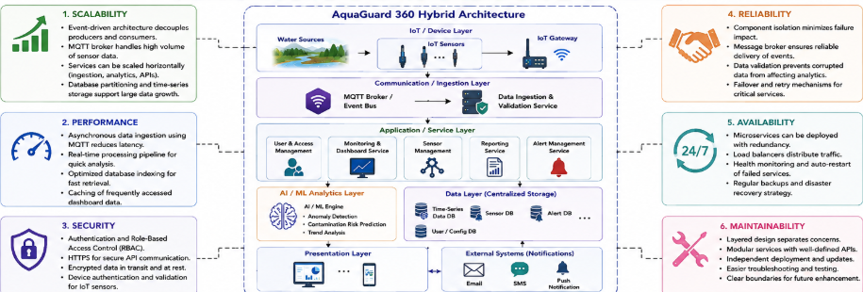

14. ARCHITECTURAL DECISIONS AND TRADE-OFFS
Every software architecture involves trade-offs. The Hybrid Layered and Event-Driven Architecture provides several advantages for AquaGuard 360, but it also introduces additional complexity compared with a simple standalone application.
One major architectural decision is the use of an MQTT-based event-driven data pipeline. This approach allows sensors and backend services to remain loosely coupled. Sensors publish measurements without needing direct knowledge of the AI engine, database or dashboard. This supports scalability and flexibility.
However, introducing a message broker creates another infrastructure component that must be deployed, configured and monitored. Troubleshooting asynchronous communication may also be more difficult than debugging a simple direct request-response interaction.
A second decision is separating the AI/ML Analytics Engine from the main application logic. This allows analytical models to be retrained or replaced independently and makes it easier to allocate additional processing resources to AI operations.
The trade-off is that data must be transferred between the processing, storage and analytical components. Clear interfaces and consistent data formats are therefore required.
Another decision is using a centralized data layer. Central storage simplifies historical analysis, reporting and multi-location monitoring because information is available through a common environment.
However, centralized storage can become a performance bottleneck if the volume of sensor measurements increases significantly. Database indexing, time-series storage strategies, backup mechanisms and future data partitioning may therefore become necessary.
The architecture also separates the Alert and Notification Service from the AI/ML component. This allows the system to change notification providers without modifying prediction logic. The disadvantage is that an additional communication path must be maintained between analytics and notifications.
The major architectural trade-offs can be summarized as follows.
Architectural Decision | Advantage | Trade-off
Event-driven sensor processing | Scalable and loosely coupled | More messaging complexity
Layered organization | Clear separation of responsibilities | Additional interfaces between layers
Separate AI/ML engine | Independent model development | Additional data communication
Centralized storage | Easier analysis and reporting | Potential storage bottleneck
Separate notification service | Flexible alert channels | Additional service dependency
REST API layer | Standard client communication | API security and versioning required
These trade-offs are acceptable because AquaGuard 360 requires flexibility and scalability more than the simplicity of a small standalone application.

15. FUTURE ENHANCEMENTS AND EXTENSIBILITY
An important objective of the selected architecture is to allow AquaGuard 360 to evolve without requiring complete redevelopment. The modular design provides several possibilities for future expansion.
Additional water quality sensors can be introduced by extending the device and ingestion layers. As long as new sensor measurements follow a defined message structure, the higher-level application can process additional parameters with limited architectural change.
The AI/ML layer can also evolve independently. Future versions may use more advanced time-series forecasting, contamination classification or explainable AI techniques. Models could potentially consider external environmental information such as rainfall or weather conditions alongside sensor measurements.
Geographic visualization can be introduced through a GIS or map service. Water sources could then be displayed geographically, allowing operators to identify the locations of active alerts and compare contamination patterns across regions.
A dedicated mobile application could use the existing REST API layer to provide monitoring information to field personnel without changing the core backend architecture.
The notification component can also be extended with additional communication channels. Because notification functionality is separated from prediction logic, new providers can be integrated without major changes to the AI/ML engine.
For larger deployments, services that experience high demand can be scaled independently. Cloud infrastructure can also support load balancing, replicated services and distributed data storage if monitoring expands across a large geographic region.
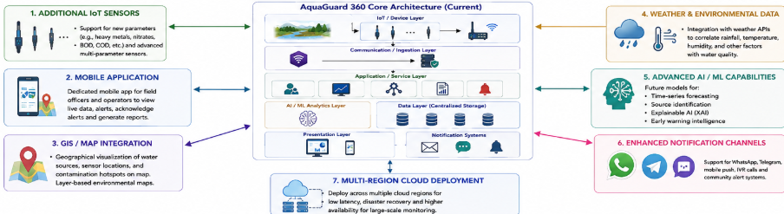
16. FINAL ARCHITECTURAL JUSTIFICATION
The Hybrid Layered and Event-Driven Architecture is suitable for AquaGuard 360 because the proposed system contains both continuous asynchronous data processing and structured user-facing application functionality.
The event-driven portion handles continuously arriving IoT measurements and supports loose coupling between sensors and processing components. MQTT-based publish/subscribe communication allows sensors to transmit information without directly depending on the database, AI/ML engine or dashboard.
The layered portion provides clear separation between device communication, data processing, application services, analytics, storage and presentation. This improves maintainability and allows different components to evolve independently.
The architecture also directly supports the important quality attributes identified in the assignment. Scalability is supported through asynchronous messaging and independent components. Performance is improved by separating real-time processing from user requests. Security is addressed through authenticated APIs, role-based authorization and protected communication. Reliability and availability benefit from component isolation, while maintainability is supported through modular design and defined interfaces.
Although this architecture is more complex than a simple monolithic application, the additional complexity is justified by the operational requirements of AquaGuard 360. The system must communicate with distributed IoT devices, continuously process sensor events, maintain historical information, execute AI/ML analysis and provide time-sensitive notifications.
The selected architecture therefore provides a suitable balance between scalability, performance, security, reliability, availability and maintainability, while also providing sufficient flexibility for future enhancements and integrations.

17. CONCLUSION
AquaGuard 360 demonstrates how software architecture can be designed around both functional requirements and quality attributes. The system requires continuous collection of water quality measurements, centralized storage, AI/ML-based contamination prediction, real-time visualization, secure access and rapid alert generation.
After analyzing these requirements, a Hybrid Layered and Event-Driven Architecture was selected. Event-driven communication is used for continuous IoT sensor processing and alert generation, while layered organization separates application services, analytics, storage and presentation responsibilities.
The detailed architecture identifies the IoT sensors, gateway, MQTT messaging infrastructure, ingestion and validation service, central database, AI/ML analytics engine, REST API layer, dashboard and notification services. Defined communication mechanisms allow these components to exchange information while remaining relatively independent.
The architecture also addresses the six major quality attributes required for the assignment: scalability, security, performance, reliability, maintainability and availability. Architectural trade-offs were considered, and the design provides a clear path for future extensions such as additional sensors, GIS integration, mobile applications, external environmental data and advanced AI/ML models.
Overall, the proposed architecture provides a scalable and maintainable technical foundation for AquaGuard 360 and supports its objective of transforming water quality monitoring from a periodic reactive process into a continuous and predictive environmental monitoring platform.

REFERENCES
- Atlassian, “Jira Software – Project and Issue Tracking,” Atlassian. Accessed: Aug. 2026.
- OASIS, “MQTT Version 5.0,” OASIS Standard, Mar. 2019.
- R. T. Fielding, Architectural Styles and the Design of Network-based Software Architectures, Doctoral Dissertation, University of California, Irvine, 2000.
- L. Bass, P. Clements, and R. Kazman, Software Architecture in Practice, 4th ed. Addison-Wesley Professional, 2021.
- I. Sommerville, Software Engineering, 10th ed. Pearson, 2015.
- R. S. Pressman and B. R. Maxim, Software Engineering: A Practitioner’s Approach, 9th ed. McGraw-Hill, 2019.
- ISO/IEC 25010:2023, Systems and Software Engineering — Systems and Software Quality Requirements and Evaluation (SQuaRE) — Product Quality Model, International Organization for Standardization, 2023.
- NIST, Internet of Things (IoT) Device Cybersecurity Guidance, National Institute of Standards and Technology.
- World Health Organization, Guidelines for Drinking-water Quality, World Health Organization, Geneva.
- U.S. Environmental Protection Agency, “Water Quality Monitoring,” United States Environmental Protection Agency.
- Microsoft Azure, “IoT Architecture and Cloud Design Patterns,” Microsoft Learn.
- Amazon Web Services, “IoT and Event-Driven Architecture,” AWS Architecture Center.
- IBM, “What is Event-Driven Architecture?”, IBM.
- Google Cloud, “Architecture Framework – Reliability, Performance and Security,” Google Cloud Documentation.
- AquaGuard 360 Project Specification, Intelligent Water Quality Monitoring and Predictive Contamination Alert System, CO2 Architecture Design Assignment, 2026.

